**Exercise Questions**

1. Write a MongoDB query to display all the documents in the collection restaurants.

> db.addresses.find()

2. Write a MongoDB query to display the fields restaurant_id, name, borough and cuisine for all the documents in the collection restaurant.

db.addresses.aggregate(

{$project: {restaurant_id:1, name:1, borough:1, cuisine:1}}

)

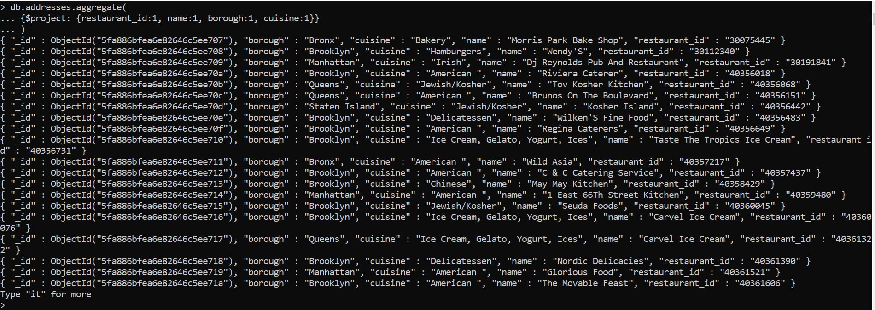

3.Write a MongoDB query to display the fields restaurant_id, name, borough and cuisine, but exclude the field _id for all the documents in the collection restaurant.

db.addresses.aggregate(

{$project: {_id : 0, restaurant_id:1, name:1, borough:1, cuisine:1}}

)

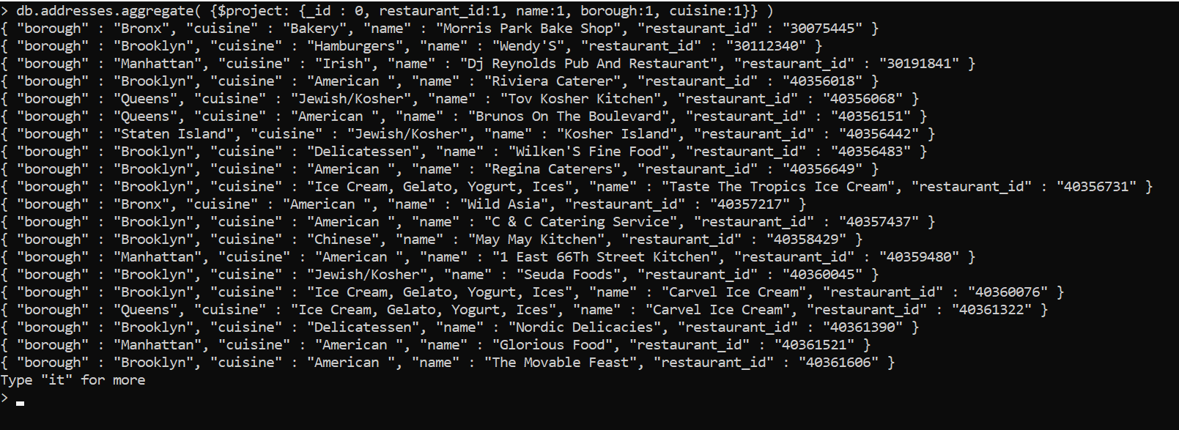

4. Write a MongoDB query to display the fields restaurant_id, name, borough and zip code, but exclude the field _id for all the documents in the collection restaurant.

db.addresses.aggregate(

{$project: {_id : 0, restaurant_id:1, name:1, borough:1, cuisine:1, “address.zipcode”:1}}

)

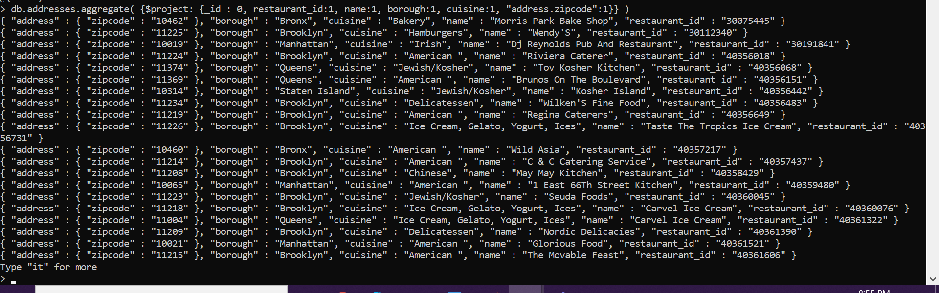

5. Write a MongoDB query to display the first 5 restaurant which is in the borough Bronx.

db.addresses.aggregate(

{$match : {"borough":"Bronx"} },

{$limit: 5}

)

6. Write a MongoDB query to display all the restaurant which is in the borough Bronx.

db.addresses.aggregate(

{$match : {"borough":"Bronx"} }

)

7. Write a MongoDB query to display the next 5 restaurants after skipping first 5 which are in the borough Bronx.

db.addresses.aggregate(

{$match : {"borough":"Bronx"} },

{$skip: 5},

{$limit: 5}

)

8. Write a MongoDB query to find the restaurants who achieved a score more than 90.******????

db.addresses.aggregate(

{$match : {"grades.score": {$gt: 90} } }

)

9. Write a MongoDB query to find the restaurants that achieved a score, more than 80 but less than 100.

db.addresses.aggregate([<[[[[[[[[

{$match : {"grades.score": {$gt: 80, $lt: 100}}}

])

db.addresses.aggregate([

... { $match: {"grades.score": {$gt: 80, $lt: 100}}}

... ])

10. Write a MongoDB query to find the restaurants which locate in latitude value less than -95.754168.

db.addresses.aggregate([

... { $match: {"address.coord": {$lt: -95.754168}}}

... ])

11. Write a MongoDB query to find the restaurants that

<do not> prepare any cuisine of 'American'

and their grade score more than 70

and <latitude> less than -65.754168.

db.addresses.aggregate([{$match: { $and: [ {"cuisine": {$ne: "American "} }, {"grades.score": {$gt: 70}}, {"address.coord": {$lt: -65.754168}} ]}}])

<--same as AND Condition example below ---->

db.addresses.aggregate([{$match: {"address.coord": {$lt: -65.754168}, "cuisine": "American ", "grades.score": {$gt: 70}}}])

12. Write a MongoDB query to find the restaurants

which do not prepare any cuisine of 'American'

and achieved a score more than 70

and located in the <longitude> less than -65.754168.

db.addresses.aggregate([

{$match: { $and: [ {"cuisine": {$ne: "American "} }, {"grades.score": {$gt: 70}}, {"address.coord": {$lt: -65.754168}} ]}}

])

13. Write a MongoDB query to find the restaurants

which do not prepare any cuisine of 'American '

and achieved a grade point 'A' not belongs to the borough Brooklyn.

The document must be displayed according to the cuisine in descending order.

db.addresses.aggregate([

{$match: { $and: [ {"cuisine": {$ne: "American "} }, {"grades.grade": "A"}, {"borough": {$ne: "Brooklyn"} } ]}},

{ $sort: {"cuisine": -1}}

])

14. Write a MongoDB query

to find the restaurant Id, name, borough and cuisine for those restaurants

which contain 'Wil' as first three letters for its name.

db.addresses.aggregate([

... { $match: { "name": {$regex: "^Wil"}}},

... { $project: {_id: 0, restaurant_id: 1, name: 1, borough: 1, cuisine: 1}}

... ])

15. Write a MongoDB query

to find the restaurant Id, name, borough and cuisine

for those restaurants which contain 'ces' as last three letters for its name.

db.addresses.aggregate([

... { $match: { "name": {$regex: "ces$"}}},

... { $project: {_id: 0, restaurant_id: 1, name: 1, borough: 1, cuisine: 1}}

... ])

OR <------------ whats the difference

db.addresses.aggregate([

... { $project: {_id: 0, restaurant_id: 1, name: 1, borough: 1, cuisine: 1}},

... { $match: { "name": {$regex: "ces$"}}}

... ])

16. Write a MongoDB query to find

the restaurant Id, name, borough and cuisine for those restaurants

which contain 'Reg' as three letters somewhere in its name.

db.addresses.aggregate([

... { $match: { "name": {$regex: "Reg"}}},

... { $project: {_id: 0, restaurant_id: 1, name: 1, borough: 1, cuisine: 1}}

... ])

17. Write a MongoDB query to find the restaurants

which belong to the borough Bronx and

prepared either American or Chinese dish.

db.addresses.aggregate([

... { $match: { $and:[ {"borough": "Bronx"}, {"cuisine": { $in: ["American ","Chinese"]}} ] }},

... { $project: {_id: 0, restaurant_id: 1, name: 1, borough: 1, cuisine: 1}}

... ])

18. Write a MongoDB query to find the restaurant Id, name, borough and cuisine for those restaurants

which belong to the borough Staten Island or Queens or Bronxor Brooklyn.

db.addresses.aggregate([

... { $match: { $or:[{"borough": { $in: ["Staten Island","Queens", "Bronx", "Brooklyn"]}} ] }},

... { $project: {_id: 0, restaurant_id: 1, name: 1, borough: 1, cuisine: 1}}

... ])

19. Write a MongoDB query to find the restaurant Id, name, borough and cuisine for those restaurants

which are not belonging to the borough Staten Island or Queens or Bronxor Brooklyn.

db.addresses.aggregate([

... { $match: { $nin:[{"borough": { $in: ["Staten Island","Queens", "Bronx", "Brooklyn"]}} ] }},

... { $project: {_id: 0, restaurant_id: 1, name: 1, borough: 1, cuisine: 1}}

... ])

20. Write a MongoDB query to find the restaurant Id, name, borough and cuisine for those restaurants

which achieved a score which is not more than 10. ????????????????????//

db.addresses.aggregate([

... { $match: { "grades.score": {$lte: 10} }},

... { $project: {_id: 0, restaurant_id: 1, name: 1, borough: 1, "grades.score": 1}}

... ])

21. Write a MongoDB query to find the restaurant Id, name, borough and cuisine for those restaurants

which prepared dish except 'American' and 'Chinees'

or restaurant's name begins with letter 'Wil'.

db.addresses.aggregate([

... { $match: { $or:[ {"name": {$regex: "^Wil"}} , {"cuisine": { $nin: ["American ","Chinese"]}} ]} },

... { $project: {_id: 0, restaurant_id: 1, name: 1, borough: 1, cuisine: 1}}

... ])

22. Write a MongoDB query to find the restaurant Id, name, and grades for those restaurants

which achieved a grade of "A"

and scored 11 on an ISODate "2014-08-11T00:00:00Z" among many of survey dates..

db.addresses.aggregate([

... { $match: { $and:[ {"grades.grade": "A"} , {"grades.score": {$eq: 11} }, {"grades.date": "2014-08-11T00:00:00Z"} ]} },

... { $project: {_id: 0, restaurant_id: 1, name: 1, "grades.grade": 1, "grades.date":1,"grades.score": 1}}

... ])

23. Write a MongoDB query to find the restaurant Id, name and grades for those restaurants

where the 2nd element of grades array contains a grade of "A"

and score 9 on an ISODate "2014-08-11T00:00:00Z"

db.addresses.aggregate([

... { $match: { $and:[ {"grades.grade": "A"} , {"grades.score": {$eq: 9} } ]} },

... { $project: {_id: 0, restaurant_id: 1, name: 1, "grades.grade": 1, "grades.date":1,"grades.score": 1, secondElementofGrade: {$arrayElemAt: [ "$grades.grade", 1 ]} }}

... ])

24. Write a MongoDB query to find the restaurant Id, name, address and geographical location for those restaurants

where 2nd element of coord array contains a value which is more than 42 and upto 52..

25. Write a MongoDB query to arrange the name of the restaurants in ascending order along with all the columns.

db.addresses.aggregate([

{ $sort: {"name": 1}}

])

26. Write a MongoDB query to arrange the name of the restaurants in descending along with all the columns.

db.addresses.aggregate([

{ $sort: {"name": -1}}

])

27. Write a MongoDB query to arranged the name of the cuisine in ascending order and for that same cuisine borough should be in descending order.

db.addresses.aggregate([

{ $sort:{"name": 1,"borough": -1} }

])

28. Write a MongoDB query to know whether all the addresses contains the street or not.

db.addresses.find({ "address.street":{ $exists: true, $ne: null } });

29. Write a MongoDB query which will select all documents in the restaurants collection where the coord field value is Double.

db.addresses.find( { "address.coord" : { $type : "double"} } );

30. Write a MongoDB query which will select the restaurant Id, name and grades for those restaurants

which returns 0 as a remainder after dividing the score by 7.

31. Write a MongoDB query to find the restaurant name, borough, longitude and attitude and cuisine for those restaurants

which contains 'mon' as three letters somewhere in its name.

db.addresses.aggregate([

... { $match: { "name": {$regex: "mon"}}},

... { $project: {_id: 0, restaurant_id: 1, name: 1, borough: 1, cuisine: 1}}

... ])

32. Write a MongoDB query to find the restaurant name, borough, longitude and latitude and cuisine for those restaurants

which contain 'Mad' as first three letters of its name.

db.addresses.aggregate([

... { $match: { "name": {$regex: "^Mad"}}},

... { $project: {_id: 0, restaurant_id: 1, name: 1, borough: 1, cuisine: 1}}

... ])

Happy Coding!!!s